# Operational Handbook - Startup Budget Tracker

Author: [Trisha Chandra](https://phonetool.amazon.com/users/trchandr)

### 1.1 Overview

Purpose of the document is to provide the overview of the [Global Capital Planning Startup Revamped Dashboard by EPA Tech](https://us-east-1.quicksight.aws.amazon.com/sn/dashboards/06533f96-c2fa-46ec-8cc4-98ab7be77326) dashboard (Startup Budget Tracker) and technical details that would help for the team to analyze any bugs or additional enhancements requests from the customers

### 1.2 Stakeholders

Business Owner: [Alicia Carver](https://phonetool.amazon.com/users/alcarver), [Shawn Yoon](https://phonetool.amazon.com/users/shawnyoo)  
SPADE Team Owner: [Trisha Chandra](https://phonetool.amazon.com/users/trchandr)

### 1.3 Purpose of the dashboard

The dashboard provides insight into the startup cost and spent details.

The dashboard is a revamp of the existing Startup Budget Tracker and it provides increased accuracy on PO data and currency exchanges. We also have additional features that add visibility into more budget details like CAR closure status, contingency amounts which help in identifying end-to-end budget spent and ability to switch between local currency and USD. With this launch we will be deprecating the existing [dashboard](https://us-east-1.quicksight.aws.amazon.com/sn/dashboards/5579b992-20f4-487b-82fc-138a8fa03f04) and we encourage all our users to use the latest one linked in the email above.

In the previous version of the Startup Budget Tracker, PO data was coming from Lantern data source, which performed exchange rate conversion different from Coupa. We also encountered other issues like certain POs not flowing in correctly. To resolve these discrepancies, we have switched from Lantern to [PDC](https://w.amazon.com/bin/view/FinanceAutomation/Procurement_Data_Central/) data source to extract PO information. PDC data is more aligned with the committed amounts in Coupa.

### **1.4 Data Flow**

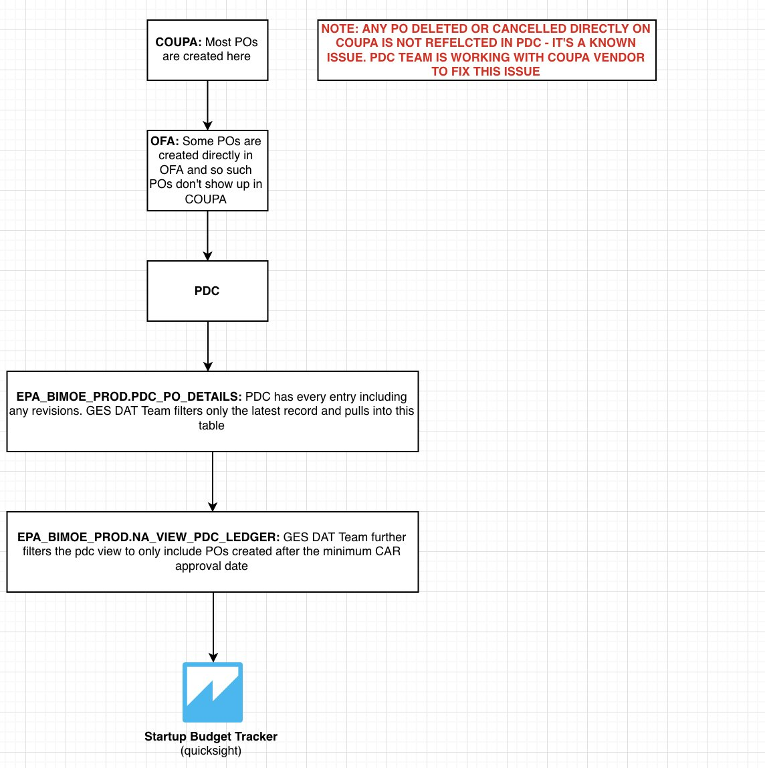

 Fig 1.a High Level Data Flow of Startup Budget Tracker Dashboard

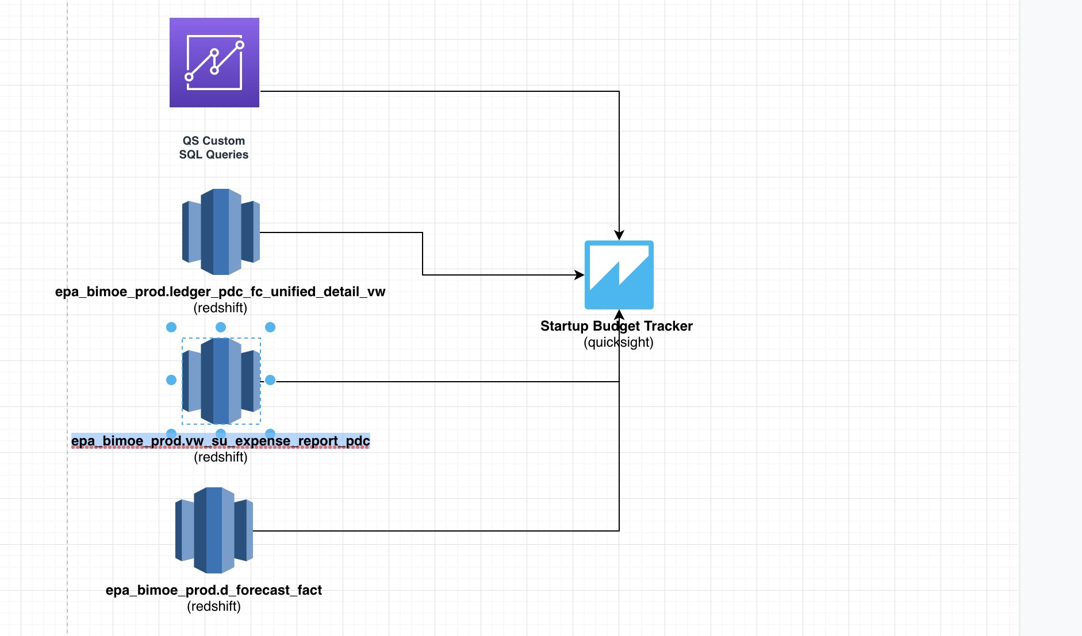

 Fig 1.b High Level Data Flow of Startup Budget Tracker Dashboard

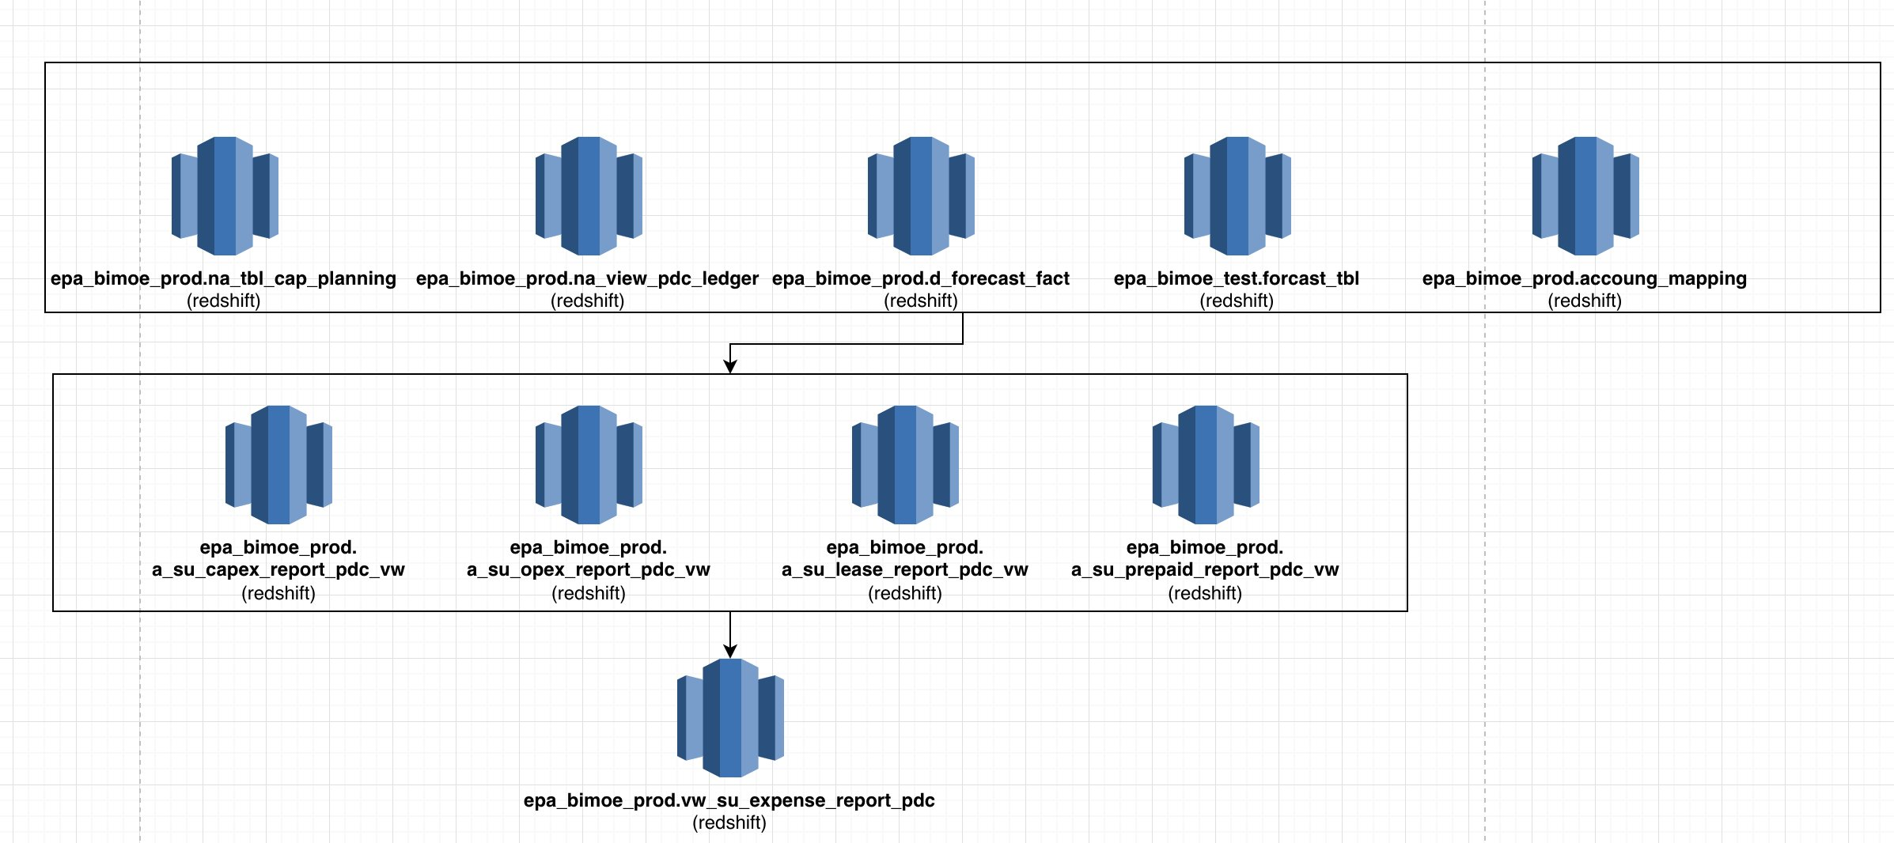

Fig 2.a Data Flow of epa_bimoe_prod.vw_su_expense_report_pdc

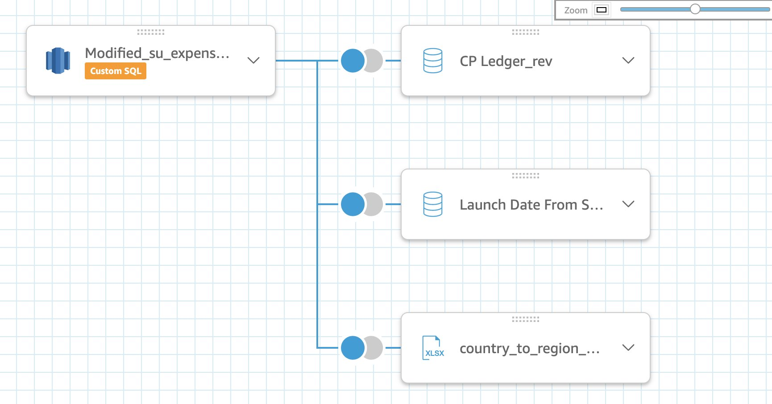

Fig 2.b Data Flow of [Modified_su_expense_report_2](https://us-east-1.quicksight.aws.amazon.com/sn/data-sets/cb0bf07b-9668-42a5-8edd-38247fc9690e/prepare) in Quicksight

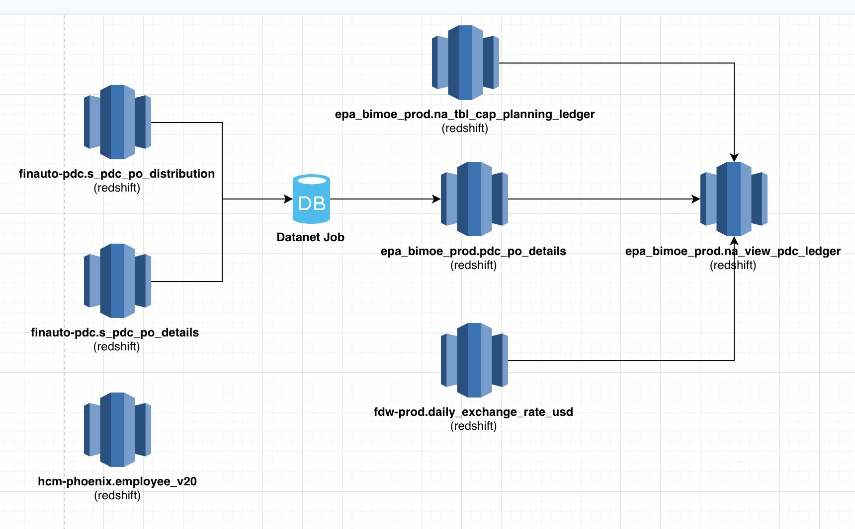

Fig 3.a Data Flow of epa_bimoe_prod.na_view_pdc_ledger

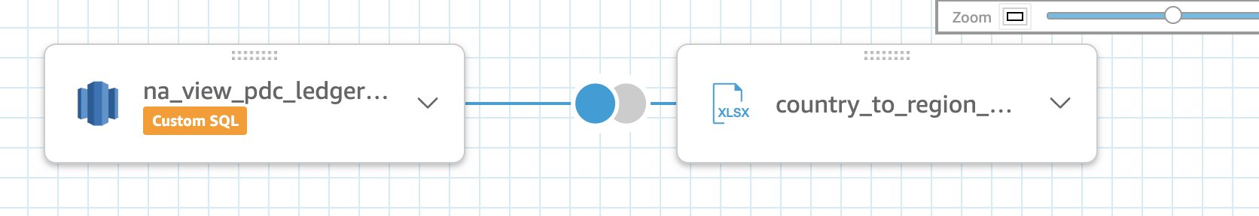

Fig 3.b Data Flow of [na_view_pdc_ledger_modified](https://us-east-1.quicksight.aws.amazon.com/sn/data-sets/06cb2f88-697a-4567-bac4-5584b50efab9/prepare)

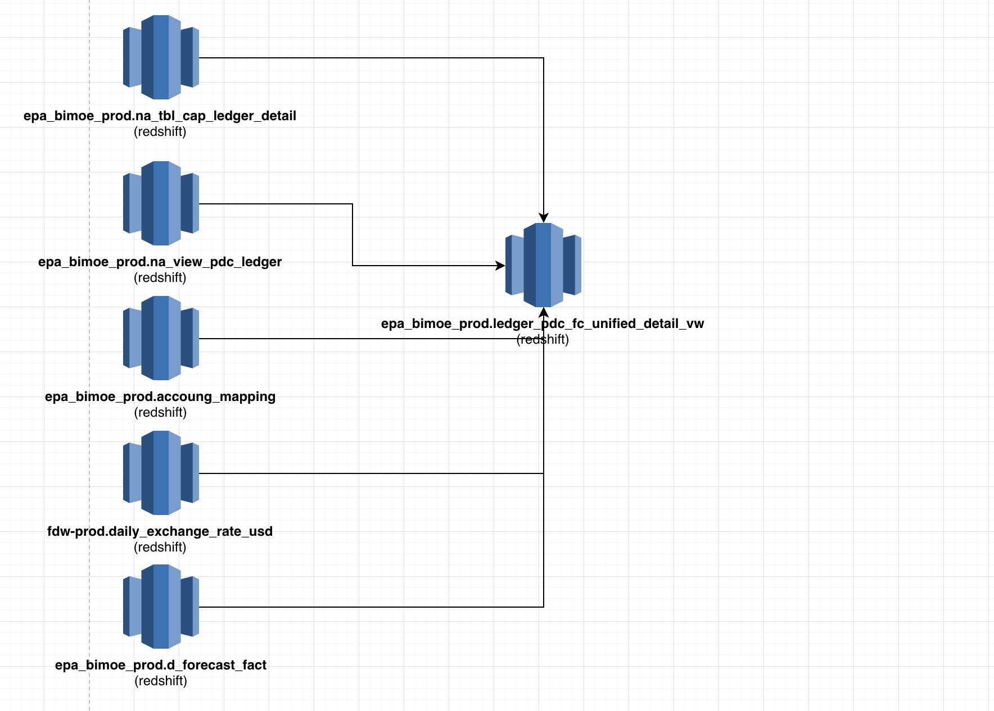

Fig 4.a Data Flow of epa_bimoe_prod.ledger_pdc_fc_unified_vw

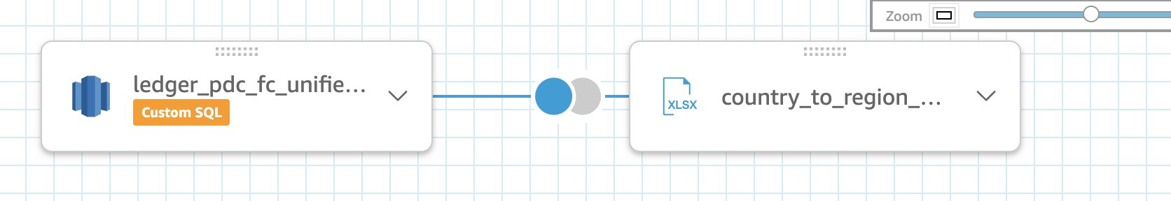

Fig 4.b Data Flow of [ledger_pdc_fc_unified_detail_modified_vw](https://us-east-1.quicksight.aws.amazon.com/sn/data-sets/cbc46976-1bd3-4dd1-9cc4-57a220af6b1e/prepare) in Quicksight

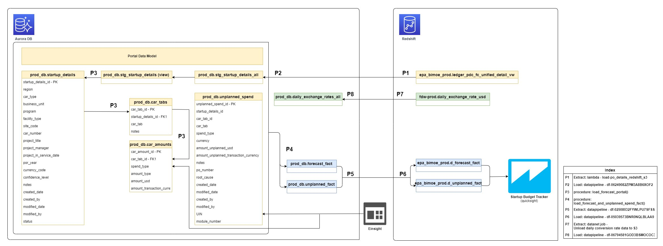

Fig 5.a High level system architecture

### 1.5 Access Requests

Currently access request is raised through this SIM template: <https://issues.amazon.com/issues/create?template=499e0ab9-9210-49f0-b362-ca6b31b4431f>

Or

Permissions can be managed via an ANT group as well. Subscribe to [bimoe-startup-reporting](https://permissions.amazon.com/group.mhtml) for access.

### 1.6 Additional Details

* More info on PDC and Lantern data mapping can be found here under **Data Validation** section of this quip: [Startup Budget Tracker](https://quip-amazon.com/aNn1A9r2CHEb)
* To make the pdc related queries run faster, we have separated the process and created daily job datanet jobs to reduce the workload from Redshift and extract only relevant info and unique entries from "finauto-pdc".s_pdc_po_distribution and "finauto-pdc".s_pdc_po_details tables into a single epa_bimoe_prod.pdc_po_details table. Job details can be found here: <https://datacentral.a2z.com/dw-platform/servlet/dwp/template/EtlViewExtractJobs.vm/job_profile_id/10069434>
* Many data discrepancies can be resolved by reading through the [READ ME](https://us-east-1.quicksight.aws.amazon.com/sn/dashboards/06533f96-c2fa-46ec-8cc4-98ab7be77326/sheets/06533f96-c2fa-46ec-8cc4-98ab7be77326_ea3d3845-37b1-4d11-9209-f01664bd8ed6) section of the dashboard and by taking a look at this [QUIP](https://quip-amazon.com/zDW8AR9cuDnz/Issues-with-Startup-Budget-Tracker).
* Find information on the data pipelines involving ledger data here: [Ledger Data](https://quip-amazon.com/d4QnA8R0llrx)
* epa_bimoe_prod.ledger_pdc_fc_unified_detail_vw updates Einsight with committed and approved numbers. More details on the data flow and objects used in the flow can be found [here](https://quip-amazon.com/u6WzASCxa0do/Einsight-Data-Flow#temp:C:ecf017d30e9215b41989897476e6).

### 1.7 Datasets used in each the dashboard tabwise:

|  |  |  |  |  |  |  |  |
| --- | --- | --- | --- | --- | --- | --- | --- |
|  | Tab Number/Name | Visual | Quicksight Dataset Name | Redshift View | Data Lake View Name | QS Custom SQL or View? | Note |
| 1 | 1. Budget Tracker - Summary | All | [ledger_pdc_fc_unified_detail_modified_vw](https://us-east-1.quicksight.aws.amazon.com/sn/data-sets/cbc46976-1bd3-4dd1-9cc4-57a220af6b1e/prepare) | [ledger_pdc_fc_unified_detail_vw](http://tiny.amazon.com/t5n4t82e/codeamazpackGESDblobmainReds) | capital_planning_refine.ledger_pdc_fc_unified_detail | View | This QS dataset left joins with an Excel sheet that maps country with AMZN Region |
| 2 | 2. Budget Tracker - Site | 2.1 | [CP Ledger](https://us-east-1.quicksight.aws.amazon.com/sn/data-sets/10f00cc3-eb30-4905-a7ae-8938a78b8e9d/prepare) |  |  | QS Custom SQL |  |
| 3 | 2. Budget Tracker - Site | 2.2 | [CP Ledger](https://us-east-1.quicksight.aws.amazon.com/sn/data-sets/10f00cc3-eb30-4905-a7ae-8938a78b8e9d/prepare) |  |  | QS Custom SQL |  |
| 4 | 2. Budget Tracker - Site | 2.3 | [ledger_pdc_fc_unified_detail_modified_vw](https://us-east-1.quicksight.aws.amazon.com/sn/data-sets/cbc46976-1bd3-4dd1-9cc4-57a220af6b1e/prepare) | [ledger_pdc_fc_unified_detail_vw](http://tiny.amazon.com/t5n4t82e/codeamazpackGESDblobmainReds) | capital_planning_refine.ledger_pdc_fc_unified_detail | View | On the QS end this dataset left joins with an Excel sheet that maps country with AMZN Region |
| 5 | 2. Budget Tracker - Site | 2.4 | [ledger_pdc_fc_unified_detail_modified_vw](https://us-east-1.quicksight.aws.amazon.com/sn/data-sets/cbc46976-1bd3-4dd1-9cc4-57a220af6b1e/prepare) | [ledger_pdc_fc_unified_detail_vw](http://tiny.amazon.com/t5n4t82e/codeamazpackGESDblobmainReds) | capital_planning_refine.ledger_pdc_fc_unified_detail | View | On the QS end this dataset left joins with an Excel sheet that maps country with AMZN Region |
| 6 | 2. Budget Tracker - Site | 2.5 | [ledger_pdc_fc_unified_detail_modified_vw](https://us-east-1.quicksight.aws.amazon.com/sn/data-sets/cbc46976-1bd3-4dd1-9cc4-57a220af6b1e/prepare) | [ledger_pdc_fc_unified_detail_vw](http://tiny.amazon.com/t5n4t82e/codeamazpackGESDblobmainReds) | capital_planning_refine.ledger_pdc_fc_unified_detail | View | On the QS end this dataset left joins with an Excel sheet that maps country with AMZN Region |
| 7 | 2. Budget Tracker - Site | 2.6 | [SU Forecast 2 (local currency upgrade)SPICE](https://us-east-1.quicksight.aws.amazon.com/sn/data-sets/b681b414-bde4-4ee2-a15b-809d80dbc5f1/prepare) |  |  |  |  |
| 8 | 2. Budget Tracker - Site | 2.7 | [SU Unplanned Spend 2](https://us-east-1.quicksight.aws.amazon.com/sn/data-sets/18c2cf63-cefd-42b7-a8cd-adda9aeb673e/prepare) |  |  |  |  |
| 9 | 3. Raw PO Data | 3.1 | [na_view_pdc_ledger_modified](https://us-east-1.quicksight.aws.amazon.com/sn/data-sets/06cb2f88-697a-4567-bac4-5584b50efab9/prepare) | [na_view_pdc_ledger](http://tiny.amazon.com/68md4lxc/codeamazpackGESDblobmainReds) | capital_planning_refine.pdc_ledger | View | On the QS end this dataset left joins with an Excel sheet that maps country with AMZN Region |
| 10 | 3. Raw PO Data | 3.2 | [LedgerVsPDC-Car Approval Comparison](https://us-east-1.quicksight.aws.amazon.com/sn/data-sets/7958879f-4b8b-4722-88cf-daecd9343a32/prepare) |  |  | QS Custom SQL |  |
| 11 | 4. Expense Report | All | [Modified_su_expense_report_2](https://us-east-1.quicksight.aws.amazon.com/sn/data-sets/cb0bf07b-9668-42a5-8edd-38247fc9690e/prepare) | [vw_su_expense_report_pdc](http://tiny.amazon.com/jlzmbngd/codeamazpackGESDblobmainReds) | capital_planning_refine.su_expense_report_pdc | View | On the QS end this dataset is joined with 3 other datasets:  1. An Excel sheet that maps country with AMZN Region 2. [CP Ledger_rev](https://us-east-1.quicksight.aws.amazon.com/sn/data-sets/599ad969-1502-4b50-b737-1f1f88631162/prepare) 3. [Launch Date from Shield](https://us-east-1.quicksight.aws.amazon.com/sn/data-sets/f0f6f112-3526-4f96-b968-aaf0a3194dab/prepare) |
| 12 | 4.1 Expense Report with Tax/Freight | All | [Modified_su_expense_report_2](https://us-east-1.quicksight.aws.amazon.com/sn/data-sets/cb0bf07b-9668-42a5-8edd-38247fc9690e/prepare) | [vw_su_expense_report_pdc](http://tiny.amazon.com/jlzmbngd/codeamazpackGESDblobmainReds) | capital_planning_refine.su_expense_report_pdc | View | On the QS end this dataset is joined with 3 other datasets:  1. An Excel sheet that maps country with AMZN Region 2. [CP Ledger_rev](https://us-east-1.quicksight.aws.amazon.com/sn/data-sets/599ad969-1502-4b50-b737-1f1f88631162/prepare) 3. [Launch Date from Shield](https://us-east-1.quicksight.aws.amazon.com/sn/data-sets/f0f6f112-3526-4f96-b968-aaf0a3194dab/prepare) |
| 13 | 5. CAR Closing Status | All | [CARClosingStatus_SU](https://us-east-1.quicksight.aws.amazon.com/sn/data-sets/27a77412-5eb2-438b-ba96-eb37c483691e/prepare) |  |  | QS Custom SQL |  |
| 14 | 7. MHE Change Order Budget Tracker | 7.5 | [a_startup_mhe_co_report_vw](https://us-east-1.quicksight.aws.amazon.com/sn/data-sets/3f04538d-6b68-423e-bb93-47c60290d45f/prepare) | Not added in the code yet but the view name is: epa_bimoe_prod.a_startup_mhe_co_report_vw | capital_planning_refine.startup_mhe_co_report | View | If the stakeholder complains regarding data refresh, pls make sure to check following 2 datanet jobs: 1. <https://datacentral.a2z.com/dw-platform/servlet/dwp/template/DWPJobPerformanceHistory.vm/job_id/18278224> 2. <https://datacentral.a2z.com/dw-platform/servlet/dwp/template/EtlViewLoadJobs.vm/job_profile_id/856742>  2nd Job (built by our team) depends on the 1st Job by the PETS team. If the first job fails or is in "waiting for ..." state for long, please reach out to dornalan@ from PETS team. |
| 15 | 7. MHE Change Order Budget Tracker | 7.6 | [a_startup_mhe_co_appsheet_vw](https://us-east-1.quicksight.aws.amazon.com/sn/data-sets/3e060372-999a-4058-88b7-29a3e03b2554/prepare) |  | appsheet_refine.startup_mhe_co_appsheet |  |  |
| 16 | 7. MHE Change Order Budget Tracker | 7.7 | [a_startup_mhe_co_detailed_po_vw](https://us-east-1.quicksight.aws.amazon.com/sn/data-sets/d406dbe4-6860-42ed-8272-e1c2b844b1a8/prepare) |  | gcp_lantern_refine.startup_mhe_co_detailed_po |  |  |
| 17 | 8. MHE Email Report | All | [a_startup_mhe_co_report_modified_vw](https://us-east-1.quicksight.aws.amazon.com/sn/data-sets/86c6dced-07ef-48a0-82ff-819174d27945/prepare) | Not added in the code yet but the view name is: epa_bimoe_prod.a_startup_mhe_co_report_vw | capital_planning_refine.startup_mhe_co_report | View | If the stakeholder complains regarding data refresh, pls make sure to check following 2 datanet jobs: 1. <https://datacentral.a2z.com/dw-platform/servlet/dwp/template/DWPJobPerformanceHistory.vm/job_id/18278224> 2. <https://datacentral.a2z.com/dw-platform/servlet/dwp/template/EtlViewLoadJobs.vm/job_profile_id/856742>  2nd Job (built by our team) depends on the 1st Job by the PETS team. If the first job fails or is in "waiting for ..." state for long, please reach out to dornalan@ from PETS team. |
| 18 | 9. Raw Ledger Data | All | [Raw Ledger Data](https://us-east-1.quicksight.aws.amazon.com/sn/data-sets/dd8b329b-0be8-4ec5-9235-f4dc5a3cb4f0/prepare) |  |  | QS Custom SQL |  |
| 19 | 10. GL Code Mismatch Report - PO vs CAR | All | [PO Mismatch](https://us-east-1.quicksight.aws.amazon.com/sn/data-sets/315d38a3-fe2c-40ae-9c66-99a31862f1bf/prepare) | Not added in the code yet but the view name is: epa_bimoe_prod.tbl_historical_car_cost_detail |  | QS Custom SQL |  |

Other underlying views:

|  |  |  |
| --- | --- | --- |
|  | Final view | Underling views (Cope repo in hyperlink) |
| 1 | [vw_su_expense_report_pdc](http://tiny.amazon.com/jlzmbngd/codeamazpackGESDblobmainReds) | [a_su_capex_report_pdc_vw](http://tiny.amazon.com/18uxwgrxi/codeamazpackGESDblobmainReds) |
| 2 |  | [a_su_opex_report_pdc_vw](http://tiny.amazon.com/12kbrxk2y/codeamazpackGESDblobmainReds) |
| 3 |  | [a_su_prepaid_report_pdc_vw](http://tiny.amazon.com/1cjt67zp6/codeamazpackGESDblobmainReds) |
| 4 |  | [a_su_lease_report_pdc_vw](https://code.amazon.com/packages/GES-DAT-SQL-DDL/blobs/mainline/--/Redshift/bimoeredshift/schemas/epa_bimoe_prod/views/a_su_lease_report_pdc_vw.sql) |

### 1.8 FAQs

1. What is the dashboard refresh cadence?  
   Daily at 1:00 am and 2:00 pm PT
2. What is the source data refresh cadence?  
   SHIELD Data Refresh - Daily at 12:00 am PT  
   Ledger Refresh - Daily at 1 AM and 2:00 pm PT
3. Are there any expected future source data changes that will impact this dashboard?  
   Addition of invoice information in the views
4. Are there any known issues ?   
   Please visit this [QUIP](https://quip-amazon.com/zDW8AR9cuDnz/Issues-with-Startup-Budget-Tracker).
5. Whom should we reach out to from stakeholders before notifying any issues ?
   1. [Alicia Carver](https://phonetool.amazon.com/users/alcarver), [Shawn Yoon](https://phonetool.amazon.com/users/shawnyoo)
   2. Who is the backup for this dashboard in case if you are not available to clarify any questions ?  
       [Minghao Yu](https://phonetool.amazon.com/users/jtsou)
   3. What is the ANT group used to give access to the dashboard ?  
      [bimoe-startup-reporting (ANT Group)](https://permissions.amazon.com/group.mhtml?action=finished&expires=&is_temporary=false&name=larri&request=616297966&target=19233133&type=ANT%20User)